**Learning Outcomes**

1. Custom ListView Control

**Custom ListView**

One of the most common controls in Android apps, to represent list of data with pics and Info.Design customrow.axml or add it from the commons folder. The custom row denotes a single row in a list.

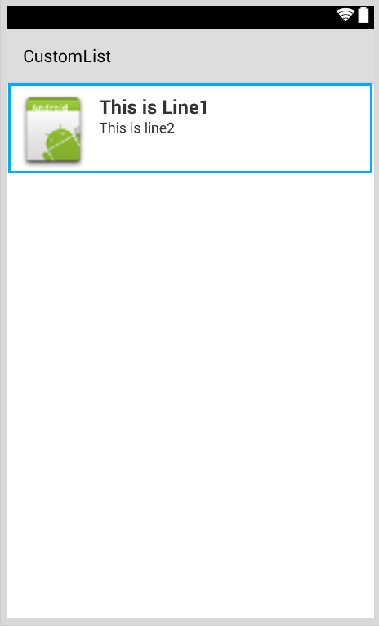

Image

Text2

Text1

<?xml version="1.0" encoding="utf-8"?>  
<RelativeLayout xmlns:android="http://schemas.android.com/apk/res/android"  
    android:layout_width="fill_parent"  
    android:layout_height="wrap_content"  
    android:padding="8dp">  
    <ImageView  
        android:id="@+id/Image"  
        android:layout_width="80dp"  
        android:layout_height="80dp"  
        android:layout_alignParentLeft="true"  
        android:layout_marginRight="8dp"  
        android:src="@drawable/icon" />  
    <TextView  
        android:id="@+id/Text1"  
        android:layout_width="wrap_content"  
        android:layout_height="wrap_content"  
        android:layout_alignTop="@id/Image"  
        android:layout_toRightOf="@id/Image"  
        android:layout_marginTop="5dip"  
        android:text="This is Line1"  
        android:textSize="20dip"  
        android:textStyle="bold" />  
    <TextView  
        android:id="@+id/Text2"  
        android:layout_width="fill_parent"  
        android:layout_height="wrap_content"  
        android:layout_below="@id/Text1"  
        android:layout_marginTop="1dip"  
        android:text="This is line2"  
        android:textSize="15dip"  
        android:layout_toRightOf="@id/Image" />  
</RelativeLayout>

Then you can design your main.axml, which contains the header and a listview.

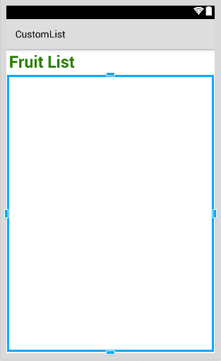

**Create a new class**

Call it **Data.cs**

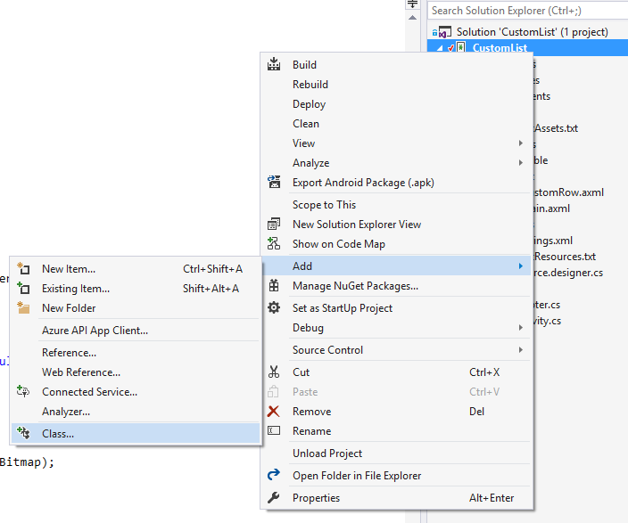

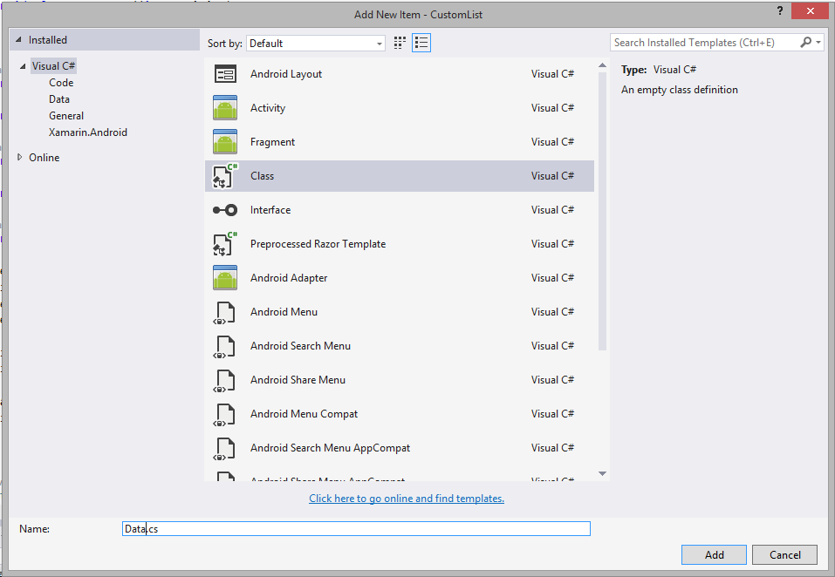

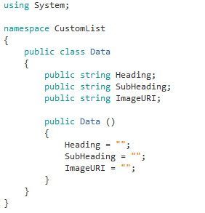

Every row in a listview represents an object of class Data.

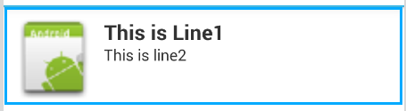

SubHeading

Heading

ImageURI

**Copy the DataAdapter.cs given to you**

In the get view function you do your modification for the custom row of your list.

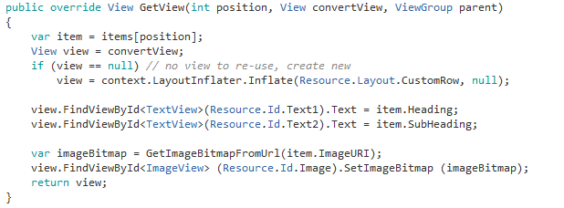

Linking the Data object with the custom row for list view

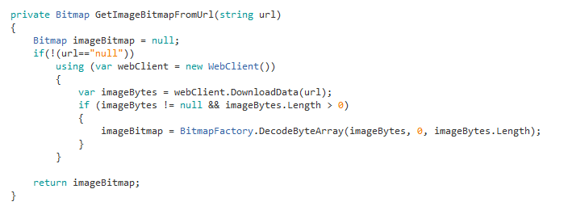

**MainActivity.cs**

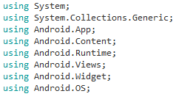

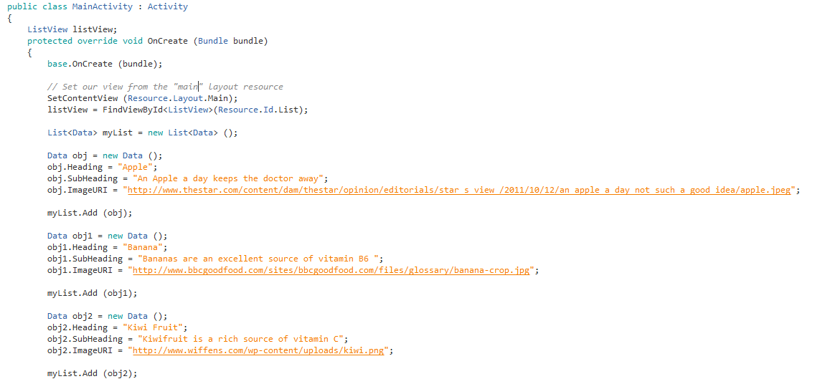

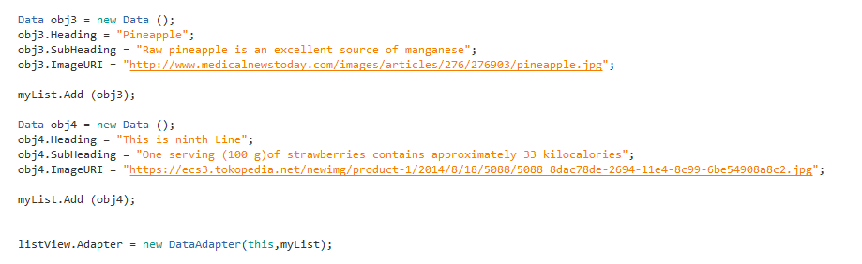

}

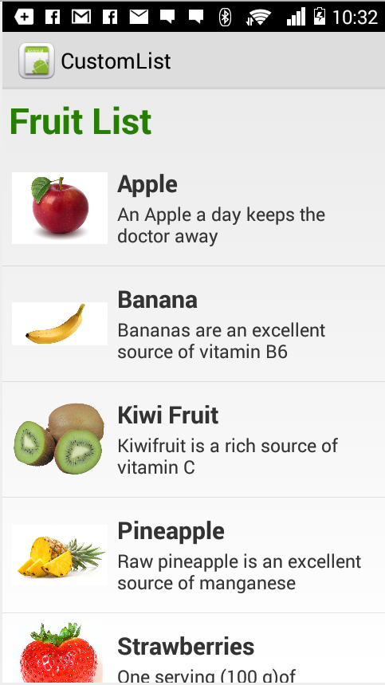

Obj2

Obj1

Obj

**Final Screen**

**Read Contacts**

Try and Implement a Custom ListView, listing all the contacts from your phone. The first line in the list shows the users display name, the second line is the phone numbers.

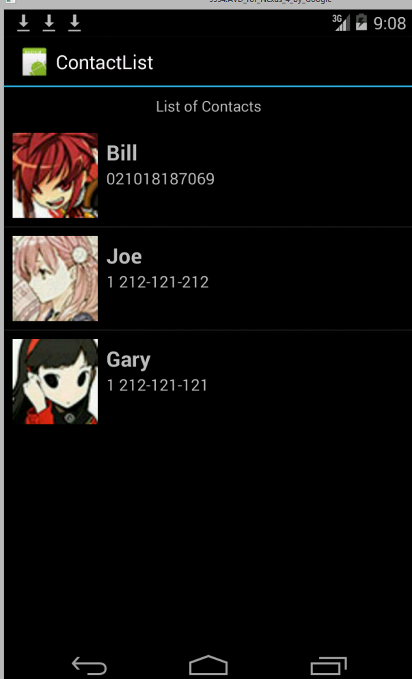

**In Components**

Import Xamarin.Contacts

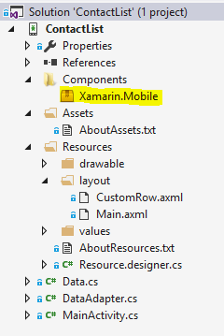

**Permissions Required** (Project - > (Project Name) Options - > Android Application)

Read Contacts



**Solution**

**Data.cs**

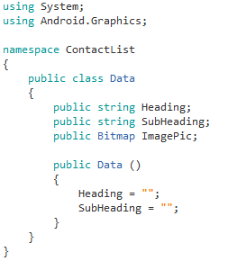

Note the change in the Data class with the Image URI replaced by the Image Pic.

**DataAdapter.cs**

**Modify the GetView function**

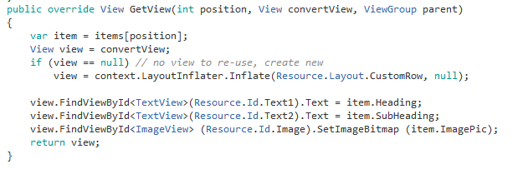

**MainActivity.cs**

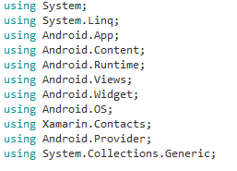

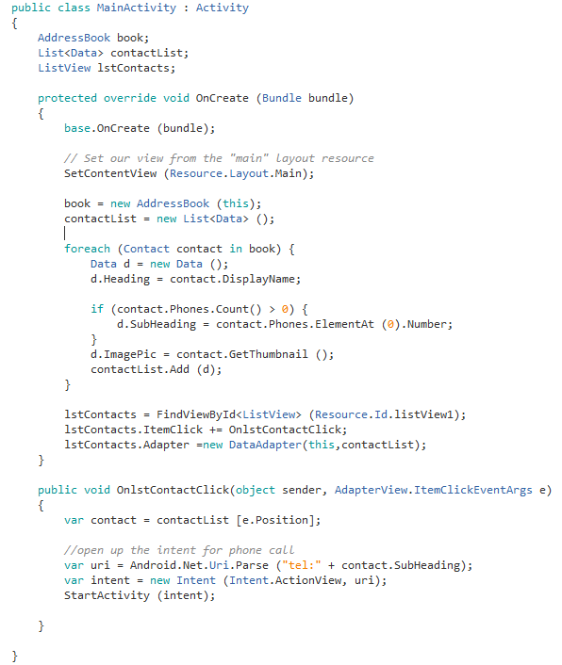

**Exercise**

1. **Write an app to list all the Apps on your phone**
2. **Write an App to show all your images from your phone and its details**